432#
Product Description: |  |  |  |  |  |  |  |  |  |  |  |  |  |  |  |  | Product Film Type:
Product Generic ID#: |  | C1T2250GI |  |  |  |  |  |  |  |  |  |  |  |  |  |  | 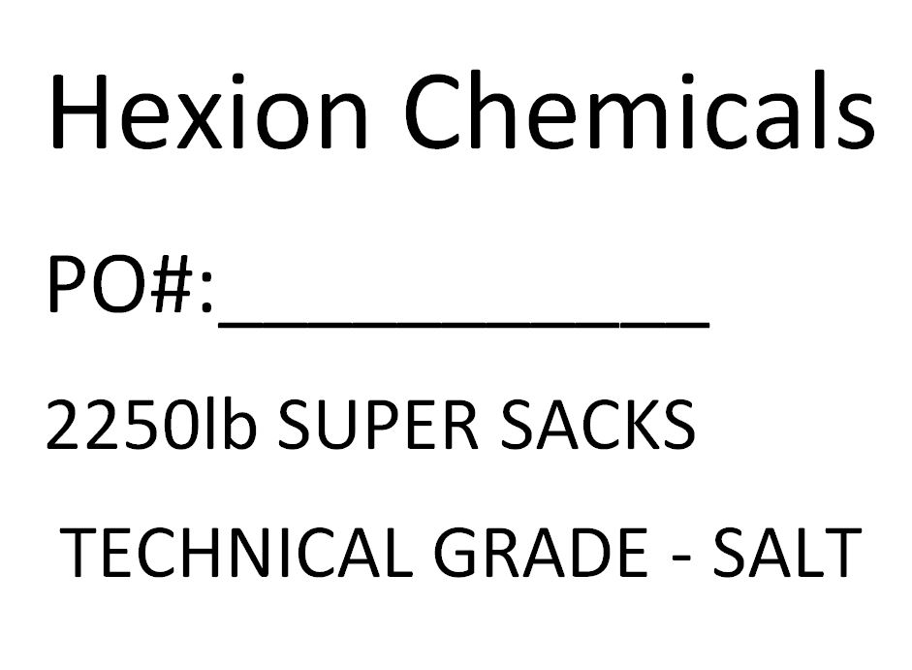
Product Grade: |  | Tech Grade
Product Screen: |  | Screened 60
Packaging Weight: |  | 2,250-lbs
Pallet Configuration: |  | 1 per pallet
Other: |  | Must be centered on pallet
Quality:
 | - Samples to be taken |  |  |  |  |  |  | Retained for:
 | - Testing Required |  |  |  |  |  |  | Testing for:
 | - Quality Release |  |  |  |  |  |  | Criteria Needed:
Production/Packaging:
 | - Shrink Wrap |  |  |  | - Liners Required |  |  |  |  |  |  |  |  | - Heat Treated Pallets |  |  |  |  |  |  |  |  |  |  | - Stickers Required
 | - Extra Placard or Tag Required: |  |  |  |  |  |  |  |  | Customer Supplied Placards.
 | - Other Requirements: |  |  |  |  |  | Super Sack Tag attached to a Sack Strap with “TSS-2250”written on back.

Shipping:
 | - General |  |  | - Air Bags |  |  |  |  |  |  |  | - Double Wrap |  |  |  |  |  |  |  |  |  | - Corner Boards |  |  |  | - Block & Brace
 | - Must have Quality Approval signature before loading: |  |  |  |  |  |  |  |  |  |  |  |  |  |  |  |  | Reason:
 |  |  |  |  |  |  |  |  | Signature: |  |  |  |  |  |  |  |  |  |  |  |  |  |  |  |  | Date:
 | - Must have Management Approval signature before loading: |  |  |  |  |  |  |  |  |  |  |  |  |  |  |  |  |  | Reason:
 |  |  |  |  |  |  |  |  | Signature: |  |  |  |  |  |  |  |  |  |  |  |  |  |  |  |  | Date:
 | - Other: |  | Cardboard skirting around walls on both dry box and container.
 | - Other: |  | COA with each shipment. COA with each BOL. Show PO# and SAP# (109931) on CoA.
 |  |  | SAP# (109931) goes in Customer Reference Section of CoA.
Change Information: |  |  | Added “cardboard skirting around walls on both dry box and container” and picture of
what “customer supplied placard” looks like.

